Install WSL 2 on Windows 10

* Enable Windows subsystem for Linux & Virtual Machine Platform, In Turn on Windows Features. REBOOT THE PC
* Go to Microsoft Stop and look for Ubuntu. After Download complete click open
* 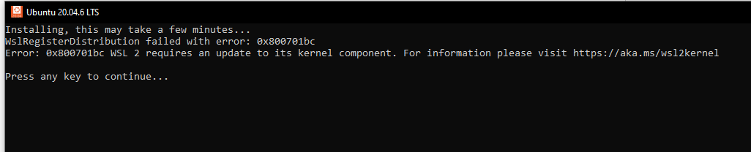
* If you get this error message you need to update kernel Go to this link: <https://aka.ms/wsl2kernel>
* Click on Wsl2 Linux Kernel update package for x64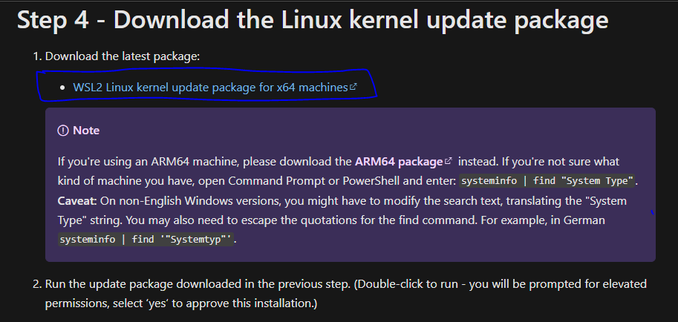
* Run & install the setup
* Now open the Ubuntu This will take a few minutes….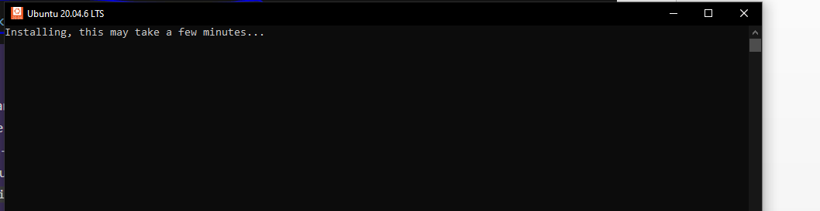
* Now enter you username and password.

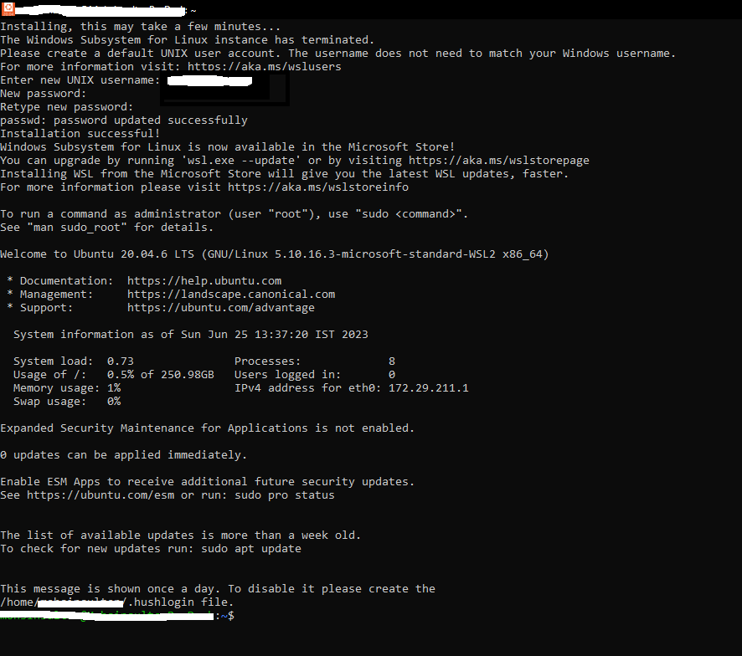

* Open PowerShell

